**Faculty Profile Template**

1. **Basic Information**

* **Name**: Toshaniwali Bhargav
* **Designation**: Assistant Professor
* **Department/School**: Computer Science & Engineering
* **Institution Name**: SSIPMT, Raipur
* **Email ID**: toshaniwali.bhargav@ssipmt.com
* **Contact Number**: 9617372009,7389722667
* **Photograph**: *(Passport-size, professional)*

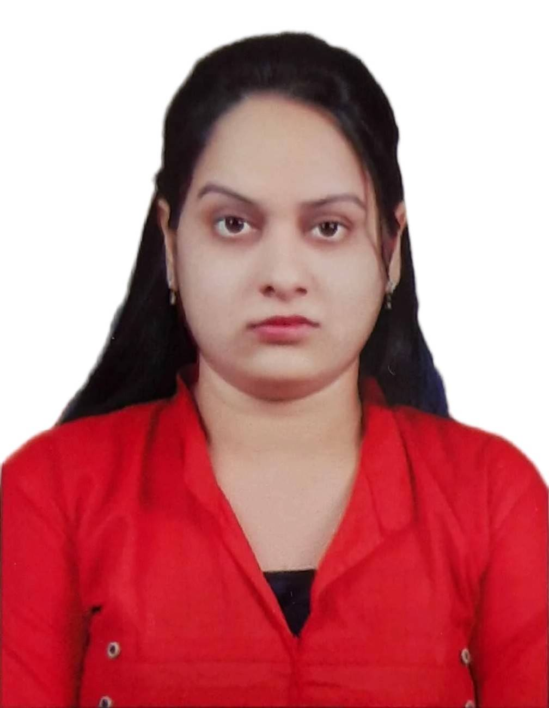

1. **Educational Qualifications**

|  |  |  |  |
| --- | --- | --- | --- |
| **Degree** | **Specialization** | **Institution** | **Year of Completion** |
| UG | B.E | CCEM, Raipur | 2012 |
| PG | M.Tech | RCET, Raipur | 2022 |
| Ph.D. | ---- | ----- | ----- |
| Others | *(if applicable)* |  |  |

1. **Teaching & Research Experience**

* **Total Teaching Experience**: 8 years
* **Industry Experience**: *(if any)- Nil*
* **Research Experience**: Nil

1. **Courses Taught**

Programming for Program Solving, Data Mining & Ware housing, Computer Network, Visual Basic, Web Technology & E-Commerce Software Engineering

1. **Research Interests / Specialization**

Artificial Intelligence, Machine Learning, IOT, Deep Learning

1. **Publications (Last 5 Years)**

* Journals (APA/IEEE format)-2
* Conference Proceedings- 2
* Book Chapters / Books Authored- Nil

1. **Research Guidance**

|  |  |  |
| --- | --- | --- |
| **Level** | **Awarded** | **Ongoing** |
| Ph.D. | Nil | Nil |
| PG | Nil | Nil |

1. **Awards & Recognitions**

Institutional

1. **Administrative Roles**

Nil

1. **Professional Memberships**

No

1. **Web Presence**

Google Scholar